Sonar Code Analysis Tool

## Sonar Description

SonarQube (Sonar) is an open source platform for continuous inspection of code quality. It will achieve developers to continuously analyze and measure source code quality.

**How to install the Sonar**

This will be useful for Ponnuswamy to write Docker Container, we need two installation components

1> SonarQube

2> SonarRunner

Both components are available as zip / tar @www.sonarqube.org/downloads/; Download and unzip the distribution at any location.

**Starting SonarQube**

We need to start the SonarQube to inspect code quality, the step to start the sonar are -

on Windows: execute StartSonar.bat

bin\windows-x86-32\StartSonar.bat

or on other platforms:

bin/[OS]/sonar.sh console

*Example* - wipro@wipro-WSG37555W7-0840:~/Sonar/sonarqube-4.5.1/bin/linux-x86-64$ sudo ./sonar.sh console

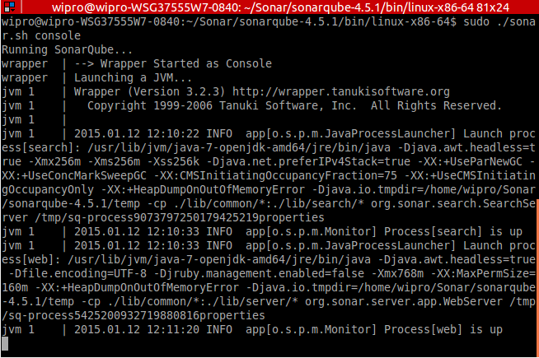

Once the Sonar is up and running, logs similar to above will be displayed.

There are different options available to execute sonar.sh is ./sonar.sh {console | start | stop | restart | status | dump}

**Executing Sonar**

1. Using Sonar runner

Sonar can be executed via SonarRunner; all the sonar property of Sonar can be found at …/Sonar/sonar-runner-2.4/conf/sonar-runner.properties, this property file contains which port sonar is running, what DB it is using and also the admin user id and password.

Go to the location of the project and then execute sonar-runner.bat

***Note***: Before you execute the project you need to provide sonar-project.properties

*Example*, execute the below commands

cd /home/wipro/Sonar/sonar-examples-master/projects/languages/java/sonar-runner/java-sonar-runner-simple

/home/wipro/Sonar/sonar-runner-2.4/bin/sonar-runner

***Without sonar-project.properties***

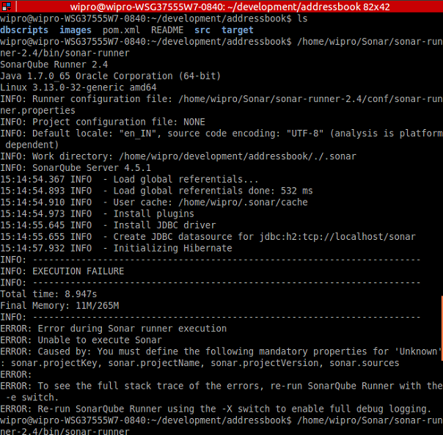

***With sonar-project.properties***



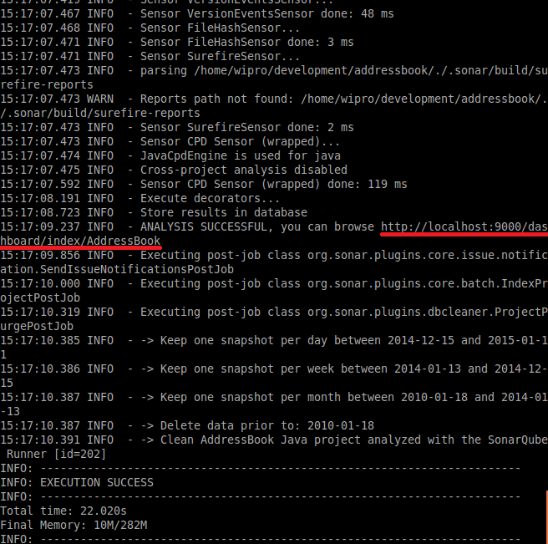

Once the execution is successful the Sonar Code Analysis result can be browsed @ <http://localhost:9000> (as highlighted above)

2> Using Maven

For MAVEN project (in our tutorial case addressBook project) Sonar can be executed using mvn command

**mvn sonar:sonar**

, in this case we do not need sonar-project.properties Sonar gets all the information from pom.xml

***Note***: Before execution, make sure the sonar-runner.properties is specified in maven settings.xml as shown below

<profile>

<id>sonar</id>

<activation>

<activeByDefault>true</activeByDefault>

</activation>

<properties>

<!-- EXAMPLE FOR MYSQL -->

<sonar.jdbc.url>

dbc:mysql://localhost:3306/sonar?useUnicode=true&amp;characterEncoding=utf8

</sonar.jdbc.url>

<sonar.jdbc.driverClassName>com.mysql.jdbc.Driver</sonar.jdbc.driverClassName>

<sonar.jdbc.username>sonar</sonar.jdbc.username>

<sonar.jdbc.password>sonar</sonar.jdbc.password>

<!-- optional URL to server. Default value is http://localhost:9000 -->

<sonar.host.url>

http://myserver:9000

</sonar.host.url>

</properties>

</profile>

Also, the properties can be specified like command argument

**mvn sonar:sonar -Dsonar.jdbc.url=jdbc:h2:tcp://ipaddr:9092/sonar -Dsonar.host.url=http://ipaddr:9000**

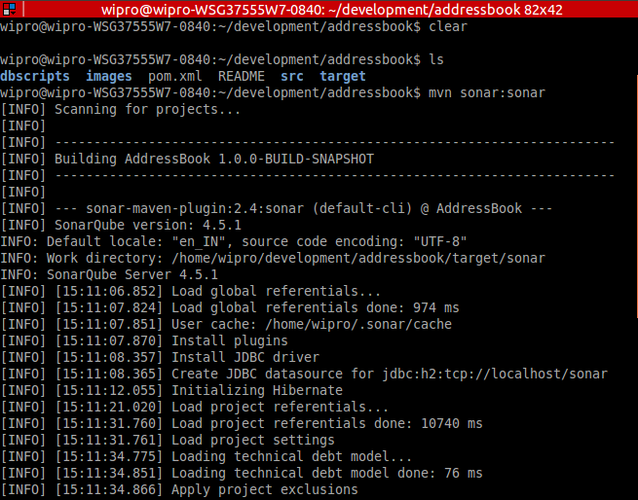

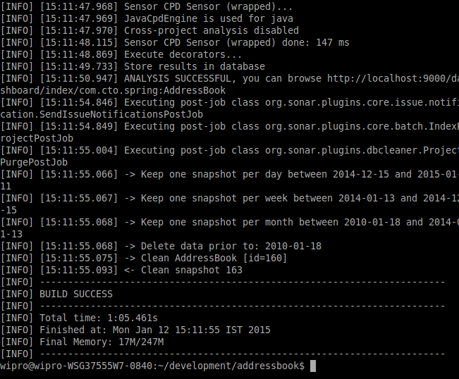

Once Sonar is successfully executed, the above logs will be displayed in the console along with the URL (<http://localhost:9000>) where the result can be browsed.

**Browse Sonar Results**

Sonar result can be browsed at (<http://localhost:9000>), a sample screen print of the Sonar result is shown below

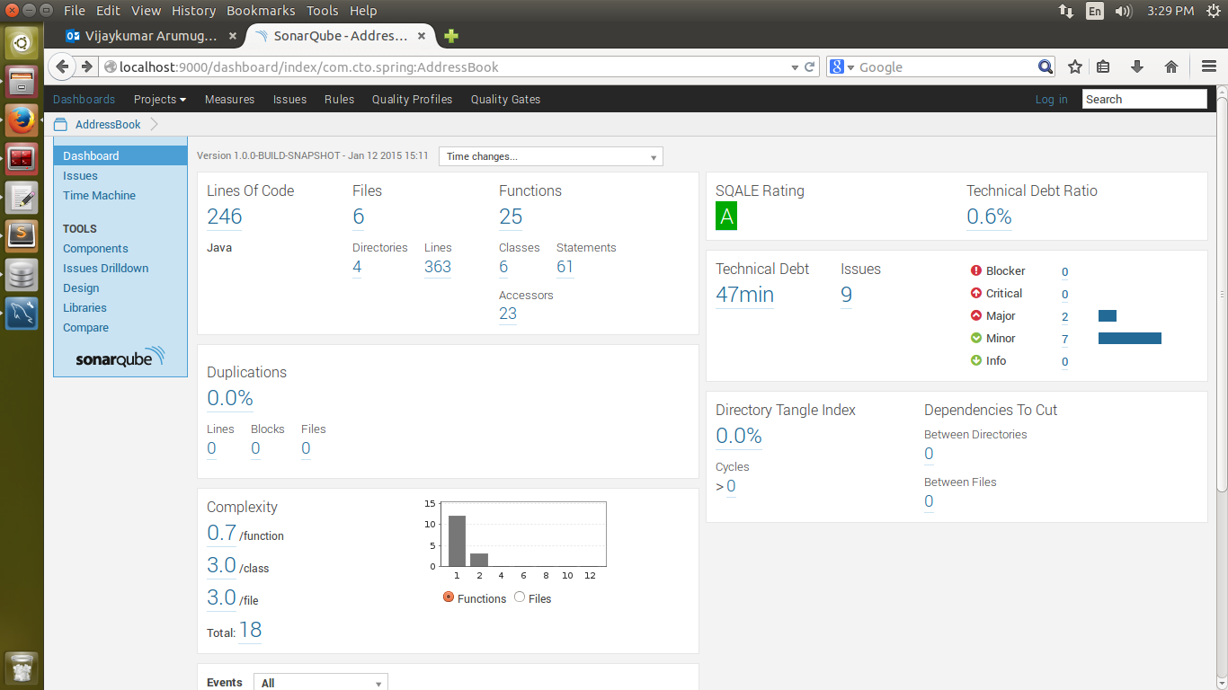

Login into Sonar Dashboard as Admin; by default, the user id and password is admin:admin.

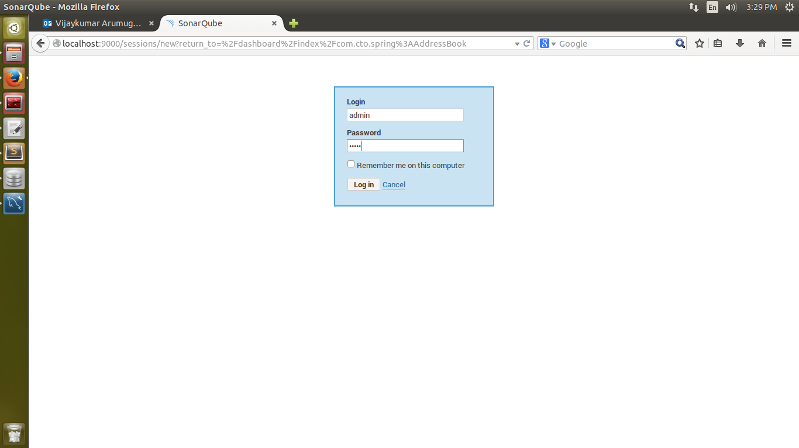

**Track Issue to closure**

All the code coverage can be seen under “issues” (as shown below), issues are classified as Critical, Major and Minor.

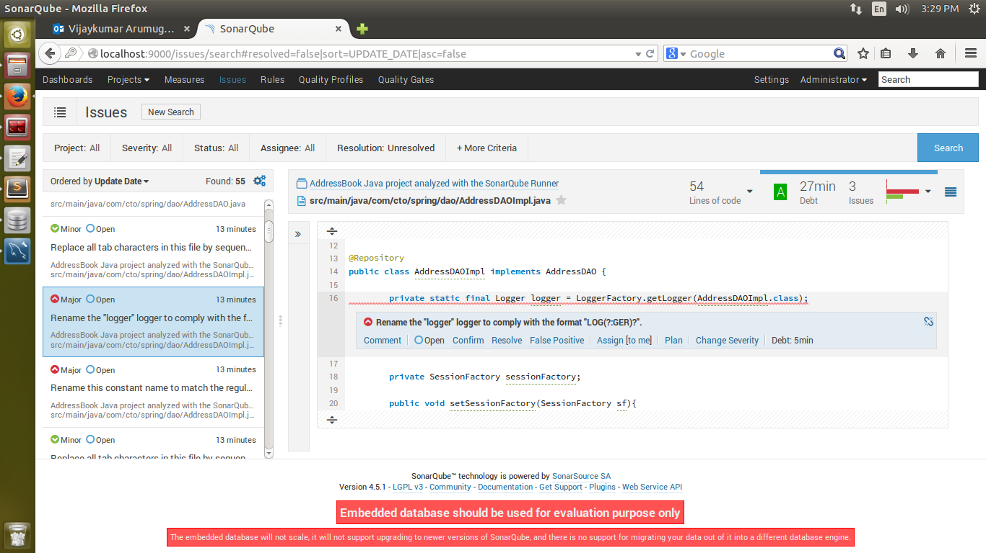

As Admin, users can be added to **Sonar using settings -> Users –> Add new user**, as shown below.

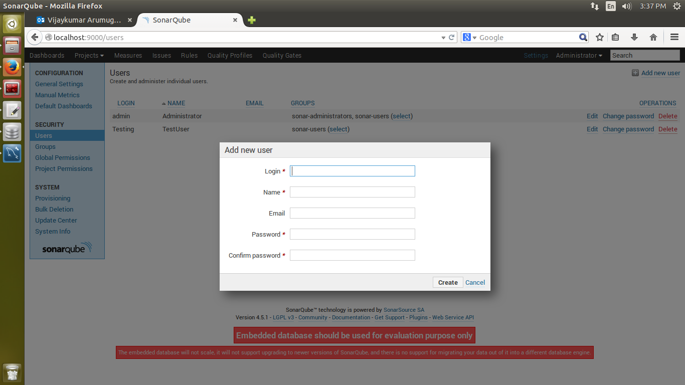

Any code coverage issues can be assigned to a specific user (as shown below, **issues -> Assign**) and he can in turn resolve the issue.

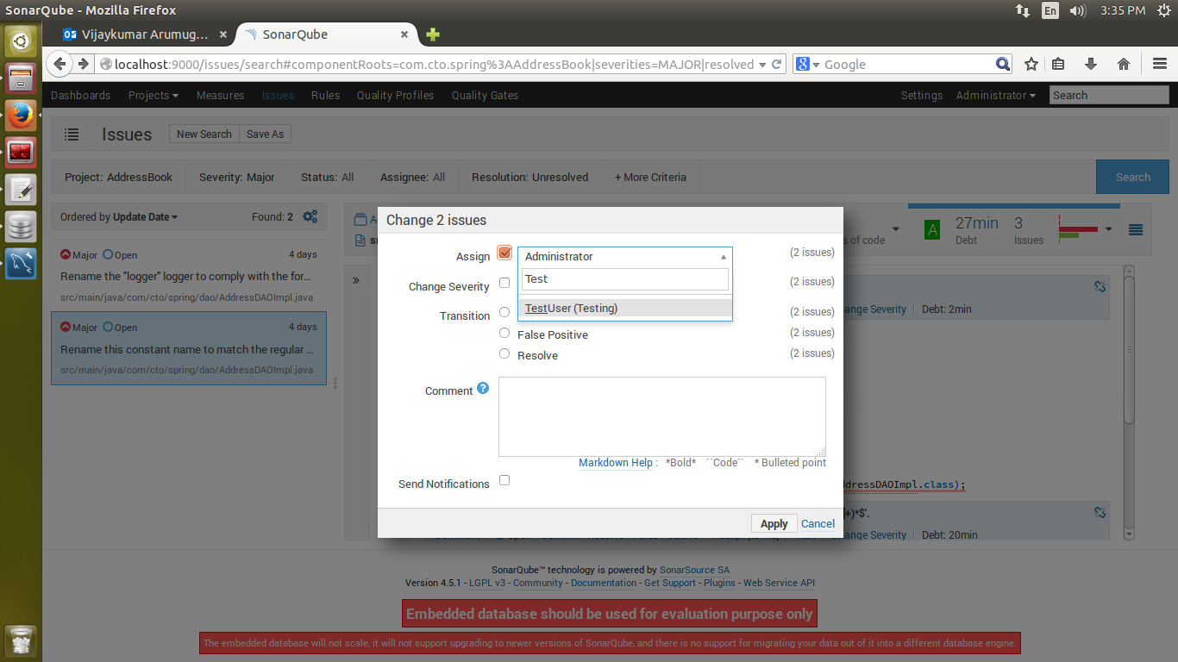

**APIs exposed by Sonar**

Sonar exposes useful APIs *for example*, to browse through the code analysis report; this can be used to generate report or other business needs

The API documentation can be found at the below links

<http://docs.codehaus.org/display/SONAR/Web+Service+API>

<http://localhost:9000/api_documentation#api/action_plans>

To use the API we need to use this JAR - sonar-ws-client-3.7.jar or if it’s a maven project we need to add the below dependency

<dependency>

<groupId>org.codehaus.sonar</groupId>

<artifactId>sonar-ws-client</artifactId>

<version>3.7.4</version>

</dependency>

<dependency>

<groupId>org.apache.httpcomponents</groupId>

<artifactId>httpclient</artifactId>

<version>4.3.1</version>

</dependency>

<dependency>

<groupId>commons-logging</groupId>

<artifactId>commons-logging</artifactId>

<version>1.1.1</version>

</dependency>

Below is an example java program to get all the

**public** **static** **void** main(String args[]) {

// Have host machine ip where the sonar is up and running

String url = "http://localHost:9000";

String login = "admin";

String password = "admin";

Sonar sonar = **new** Sonar(**new** HttpClient4Connector(**new** Host(url, login,

password)));

List<Metric> smq = sonar.findAll(MetricQuery.all());

Resource commons = **null**;

**for** (**int** i = 0; i < smq.size(); i++) {

// Provide the project key for which you want to get the metrics for

commons = sonar.find(ResourceQuery.createForMetrics(

"project key", smq.get(i).getKey()));

**if** (commons != **null**

&& commons.getMeasure(smq.get(i).getKey()) != **null**) {

System.out.println("=====================================");

System.out.println("Sonar Property for "

+ smq.get(i).getKey()

+ " is "

+ commons.getMeasure(smq.get(i).getKey())

.getFormattedValue());

}

}

}

**Lab Exercise**

1. Create user and assign one major issue (for addressBook project) for that user.
2. Resolve the issues and Execute Sonar
3. Browse the dashboard and see the difference between first and second sonar Execution

***Note***: You should be able to see graphical representation of the previous two result.